Relationships & Sex Education Policy
Venture Learning

Document Owner | Rhys Griffiths
Version | 3.0
Effective From | 01/09/2023
Next Review Date | 01/09/2024

Introduction
This policy is written in accordance with the DfE’s statement of intent for Relationships & Sex Education:
‘RSE will be age-appropriate, building knowledge and life skills over time in a way that prepares pupils for issues they will soon face. They will likely focus on:
- different types of relationships, including friendships, family relationships, dealing with strangers and, at secondary school, intimate relationships;
- how to recognise, understand and build healthy relationships, including self-respect and respect for others, commitment, tolerance, boundaries and consent, and how to manage conflict, and also how to recognise unhealthy relationships;
- how relationships may affect health and wellbeing, including mental health;
- healthy relationships and safety online; and,
- factual knowledge, at secondary school, around sex, sexual health and sexuality, set firmly within the context of relationships.’

Venture Learning believes that all children and young people have the right to high quality, comprehensive Relationships & Sex education (RSE) that promotes good sexual health, and equal and healthy relationships. We support a rights-based approach to RSE, based on qualities such as mutual respect, trust and consent.

Key Staff and Contacts

Provision Based Contacts
Name | Role
Rhys Griffiths | Chair Of Governors
Rich Hill | Headteacher
Gemma Waddington | Deputy Head of Provision
Contact details: | Venture Learning  19A Forester Street  Netherfield  Nottingham  NG4 2LJ
 | www.venturelearning.co.uk
 | 0115 987 6621 / 07587 408 996
 | Rhys.griffiths@venturelearning.co.uk
 | Rich.hill@venturelearning.co.uk

Values and Ethos

This policy covers the Venture Learning approach to how we expect our to support our children’s development and understanding around relationships, health and sex education. The policy is developed in line with the expectations of the DfE Statutory Guidance for RSE (first published in June 2019). The policy has been developed in such a way so that it can be adapted and personalised to become an academy level document. We define 'relationships and sex education' as a curriculum which will help our children grow in confidence and understanding relating to how they as individuals will develop, grow and mature into responsible individuals. We believe relationships and sex education is important for our school because it will help our children to value positive relationships and to have the confidence and strength of character to identify and lead a healthy lifestyle. We view the partnership of home and the school as vital in providing the context of open discussion, honesty and support. The intended outcomes of the programme of study is that pupils will:

Know and understand, how as ndividuals our bodies change as we get older.

Understand they have the right to be safe. o Understand they have a responsibility to be a responsible, valued member of the academy.

Develop the skills needed to lead a healthy lifestyle.

Develop the attributes of positive relationships.

Statutory Requirements & Legislation

Venture Learning follows the Department for Education statutory guidance that was statutory from September 2020. The guidance states which academies need to deliver relationships education, sex education and health education and what the RSE policy should include:

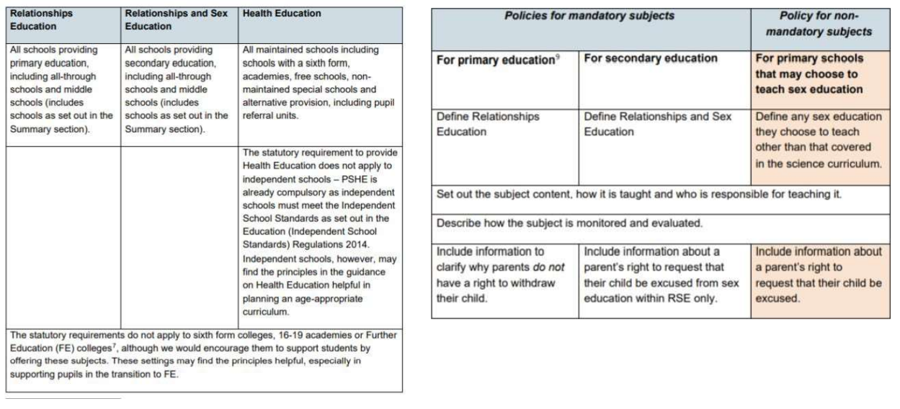

Definition

RSE teaches children and young people how to be safe and healthy. It teaches them how to manage their academic, personal and social lives in a positive way. RSE involves a combination of sharing information, exploring issues and values. RSE is not about the promotion of sexual activity or lifestyles.

Relationships Education: the focus is on teaching the fundamental building blocks and characteristics of positive relationships, with particular reference to friendships, family relationships, and relationships with other children and with adults. These areas of learning are taught within the context of family life taking care to ensure that there is no stigmatisation of children based on their home circumstances (families can include single parent families, LGBT parents, families headed by grandparents, adoptive parents, foster parents/carers amongst other structures) along with reflecting sensitively that some children may have a different structure of support around them (for example: looked after children or young carers). See Appendices for content mapping from the PSHE Association.

Health Education: the focus is on teaching the characteristics of good physical health and mental wellbeing. Teachers should be clear that mental wellbeing is a normal part of daily life, in the same way as physical health.

Sex Education: the focus is on teaching children the facts about puberty (preparing boys and girls for the changes that adolescence brings) and reproduction (how a baby is conceived and born). Parents have the right to withdraw a pupil from sex education lessons up to three months before the 16th birthday of the pupil when the child can choose to opt in.

Curriculum Design

The curriculum will take into account the age, needs and feelings of pupils. If pupils ask questions outside the scope of this policy, teachers will respond in an appropriate manner so they are fully informed and don’t seek answers online inappropriately. The RSE programme is an integral part of whole school PSHE provision and will cover: Health and Well Being, Relationships and Living in the Wider World. It:

• is inclusive of equality and diversity and academies will demonstrate this by ensuring the curriculum enables all pupils to engage with it providing pupils with knowledge and awareness from a broad spectrum of society as a whole.

• will meet the needs, or be adapted for, those children with protected characteristics through teaching which respects and acknowledges all pupils.

• supports the demographic of the locality with staff and leaders being acutely aware of common issues and needs of our pupils.

• fosters gender equality and LGBT + equality by respecting the views and feelings of all and promoting an understanding of equality through openness and respect.

• will be planned and delivered through both direct teaching time each week and also across the curriculum with the core values being modelled and embedded through daily routines. The curriculum acknowledges the range of ages and takes into account content when considering the age of the pupils it will be shared with.

• will be taught through a range of teaching methods and interactive activities.

• Will ensure that learning about relationships and sex education will link to/complement learning in topic and SMSC.

Delivery of RSE

RSE is taught within the personal, social, health and economic (PSHE) education curriculum.

Roles

The Provision Lead is ultimately responsible for ensuring that RSE is taught as part of Venture Learning’s curriculum but may choose to designate an RSE coordinator to implement the RSE policy at an operational level.

Takes responsibility for:

• ensuring that RSE is built into the curriculum as part of the schemes of work for PSHE;

• consuting with parent to ensure that parents/carers are aware of their child’s participation in RSE and and understand their right to withdraw;

• monitoring and reviewing the RSE programme;

• . updating the RSE programme to reflect changes in statutory guidance; and,

• . offering advice and guidance to staff about the teaching of RSE.’

Teaching and Support Staff

Are responsible for:

• planning and delivering RSE lessons in line with Venture Learning’s PSHE curriculum;

• modelling healthy and reapectful relationships;

• seeking guidance from the RSE Coordinator if they are uncomfortable or unsure of how to teach RSE topics; and,

• reporting any concerns that arise from RSE discussions to the Designated Safeguarding Lead.

Pupils

Pupils are expected to engage fully in RSE and, when discussing issues related to RSE, treat others with respect and sensitivity.

Safeguarding

Staff must consider how safeguarding and confidentiality protocols support safe and effective RSE practice.

• Teachers should be aware of the academy confidentiality policy.

• Teachers are aware that effective RSE, which brings an understanding of what is and what is not appropriate in a relationship, can lead to a disclosure of a child protection issue.

• Teachers will consult with the designated safeguarding lead who will follow school policy forsafeguarding.

• Visitors/external agencies which support the delivery of RSE will be required to adhere to academy safeguarding policies, confidentiality and the RSE policy.

Parents/Carers

Parents/carers play a vital role in modelling healthy relationships for their children. Open and honest discussion about relationships and sex at home can help support a young person’s moral and emotional development in this area.

If parents/carers have concerns about their child’s approach to relationships and sex they may communicate these with Venture Learning. This helps us to work together to safeguard young people, as well as meeting their educational and wellbeing needs.

Section 2: Operation of the Policy

2.1. RSE in the Curriculum

RSE will be taught as part of the PSHE curriculum at Venture Learning. Teaching staff may also facilitate RSE discussions as part of direct work if this is deemed necessary and appropriate by the Provision Lead.

Venture Learning recognises two core strands of RSE: ‘Respectful Relationships’ and ‘Safer Sexual Practice’.

The ‘Respectful Relationships’ strand of RSE aims to help students develop:

• an understanding of a range of relationships including varying boundaries and appropriate physical, emotional and social conduct in different types of relationship;

• the skills to negotiate within relationships, recognising that actions have consequences, and when and how to make compromises;

• the emotional literacy to be able to talk about feelings and relationship issues in a constructive way;

• self-esteem and respect for others to underpin positive relationships;

• the ability to recognise when a relationship is unhealthy and the knowledge of how to seek support when a relationship is in crisis; and,

• tolerance and respect for the relationships of others including those that seem unfamiliar due to religious, cultural or sexual differences.

The ‘Safer Sexual Practice’ strand of RSE aims to teach students:

• to recognise and understand the physical and emotional changes that take place at puberty and how to manage these changes in a positive way;

• about reproduction, contraception, sexually transmitted infections, HIV and high-risk behaviours including early sexual activity;

• how different forms of contraception work, and where to get advice, in order to inform future choices;

• to recognise when pressure from others threatens their personal safety and wellbeing, and to develop effective ways of resisting pressures, including knowing when and where to get help; and,

• about the importance of consent, what constitutes consent and the legal and emotional consequences of acting without consent; and,

• how to seek professional advice and help confidently for concerns about sexual health and wellbeing.

2.2. Dealing with Sensitive Issues
Teaching staff need to be sure that they are aware of issues that may arise when teaching RSE. The following guidance should be applied to RSE lessons and the facilitation of RSE discussions:

• ground rules for respectful communication should be established with the group at the outset of an RSE programme and reiterated at the start of each subsequent RSE lesson;

• no student or member of staff should be made to feel pressured to answer a personal question or contribute to the discussion;

• meanings of words should be described in a sensible and factual way;

• teaching staff should not give out personal advice about sex and relationships to students;

• teaching staff should not pass judgement on personal information that a student chooses to share;

• teaching staff may choose not to answer student’s questions if they are unsure how to answer appropriately. In these cases, they may want to refer the question to the RSE coordinator who may be able to answer or refer the student to an appropriate external agency for advice.

2.3. Parental Right to Withdraw from RSE
Parents/carers have the right to withdraw their children from non-statutory components of sex education within RSE up to and until 3 mounths before the child turns 16. After this point, if the child wishes to receive sex education rather than being withdrawn, the school will arrange this. The right to withdraw will be made clear during initial commissioning meetings. Parents/carers will also be informed about the RSE aspect of the curriculum and how to withdraw when they accept their child’s placement at Venture Learning.
Requests for withdrawal should be put in writing and addressed to the Headteacher. A copy of withdrawal request will be placed in the student’s file. The Headteacher will discuss the request with parents and take appropriate action.
The student will be provided with alternative work and supervision during sex education units of RSE lessons.

Appendix: Secondary Expectations for Secondary
